**Umamah Hussain**

**21L-1858**

**BSCS-C**

**Lab 2:**

**Q.1**

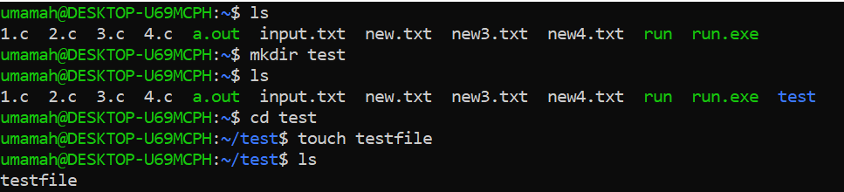

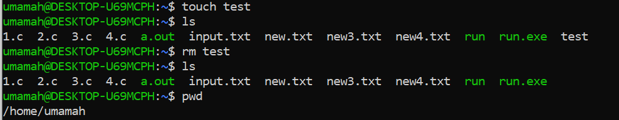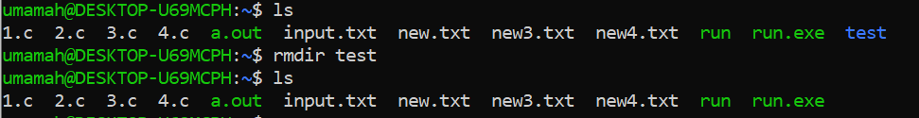

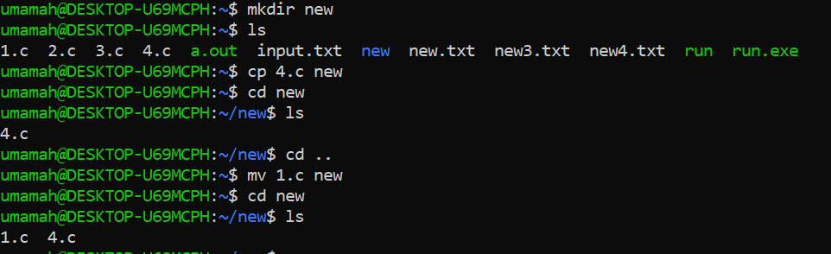

**Q.2**

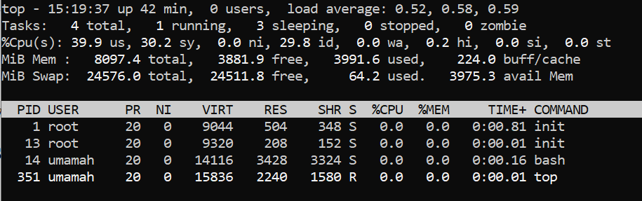

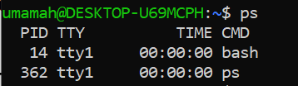

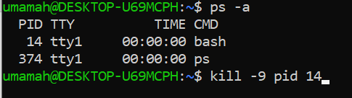

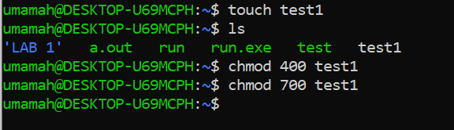

On chmod 400, writing permission was not given so the file was not being saved whereas on chmod 700, writing permission was given.

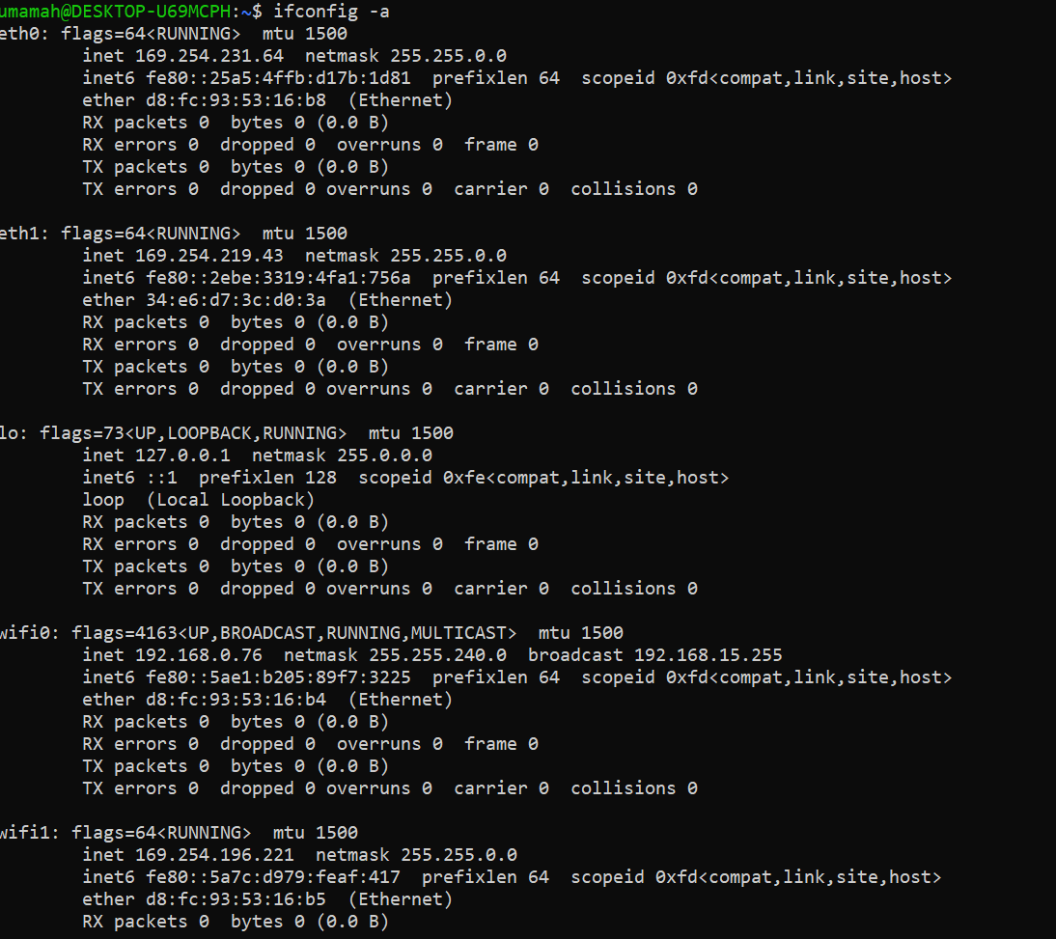 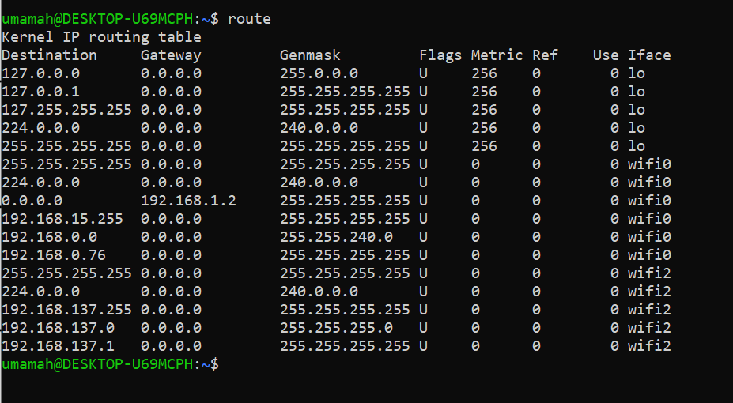 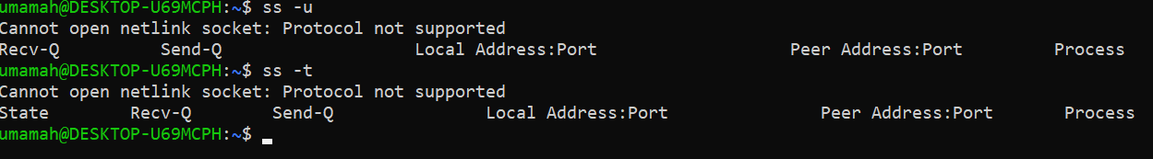 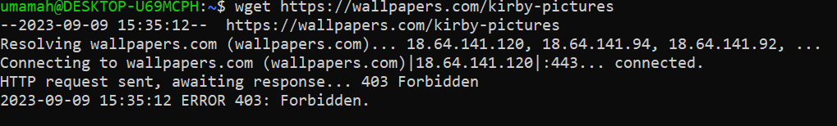 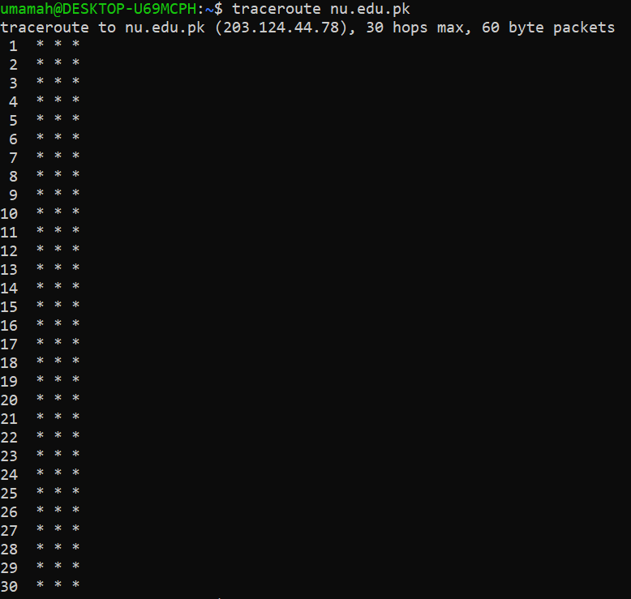 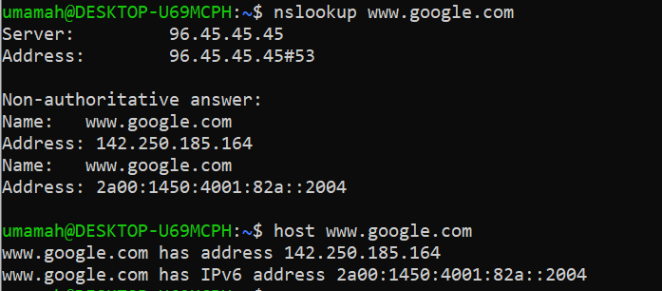

**Q.3**

